Lab No:

0
3

✵ Lab Title: Relational Operators, Logical Operators and Conditionals

o Learning objectives:
The following types will be covered in this lab session
- Comparison/Relational Operators
- Logical Operators
- If Statement
- If - else statement
- else - if Statement

 Theory: Comparison/Relational Operators

Operator Name | Syntax
Less than | a<b
Less than equal to | a<=b
Greater than | a>b
Greater than equal to | a>=b
Equal to | a==b
Not equal to | a !=b
- Logical operators:

Operator Name | Syntax
Logic Negation (not) | !a
Logic And | a && B
Logic or | a || b

- Decision Control Structures:
  - Till now we have used sequence control structure in the programs, in which the various steps are executed sequentially i.e. in the same order in which they appear in the program.
  - In C++ programming the instructions are executed sequentially, by default. At times, we need a set of instructions to be executed Depending upon different conditions to be satisfied.
  - In such cases we have to use decision control instructions. This can be achieved in C using;

    - The if statement
    - The if-else statement
    - The else - if statement  The C/C++ “if” Statement
• The if statement controls conditional branching. The body of an if statement is executed if the value of the expression/condition specified in the if statement is true. The syntax of the if statement is as follows:
Syntax:
If (expression)
{
Block of statement; }
- Example:
    - Write a program in which it takes a number from keyboard as an input and if the number is greater than 100 it prints “The number is greater than hundred”.
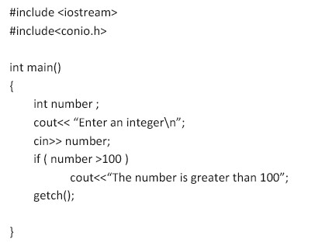

    - Note we did not use curly brackets ‘{}’for body of if if () because it did not include multiple statements (block of statements). If it includes multiple statements then it would have been something like this.
if (number<100){
cout<< “The number is greater than 100\n”;
cout<< “No doubt that the number is greater than 10
}
- The C++ if-else Statement:

• if - else statement is similar to if with the addition of else statement. If the condition is false in if then its body will be skipped and the else statement’s body will be executed.
Syntax:

if (expression)
{
Block of statement;
} else
{
Block of statement;
}
- Example:
• Write a program in which it takes two numbers from keyboard as input and subtract larger number from smaller.
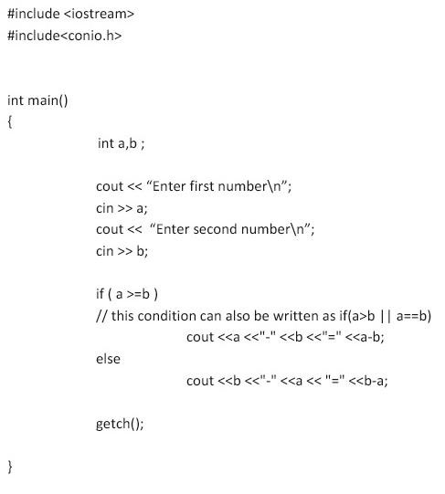

- Nested if-else statement:

• Nested if is basically if inside if.

- Example:

• Write a program which take a number from keyboard and checks the number whether that number is less than 100 or not if that number is less than 100 than check that is it less than 50 or not.
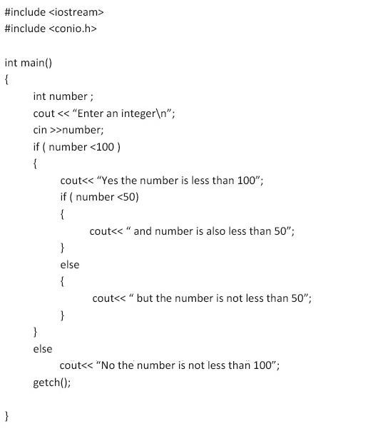

  - The above program checks if the number is less than 100. This check is done in the first if statement.
  - If the result is true the program enters the second if statement which is also called the nested if statement. Here another check is performed. The number is checked if it less than 50 or not. If the number is less than 50 it is conveyed to the user. The rest is pretty self-explanatory.

- The C++ else-if Statement:

• Sometimes we wish to make a multi-way decision based on several conditions. The most general way of doing this is by using the else if variant on the if statement. This works by cascading several comparisons. As soon as one of these gives a true result, the following statement or block is executed, and no further comparisons are performed.

Syntax:
if(expression)
{
Block of statement;
} else if(exprerssion)
{
Block of statement;
} else if(exprerssion)
{
Block of statement;
}
. . // you can add as many else-if statements as many you need
. .
. .
else
{
Block of statement;
}

- Lab Tasks:

• Task 1: Comparison/Relational Operators:
        - Write a C program that prompts the user to enter two numbers.
        - Use comparison operators to check if the first number is equal to, greater than, or less than the second number.
        - Display appropriate messages based on the comparison results.

- Input:
#include<iostream> using namespace std;
int main()
{
int num1, num2; cout<<"Enter Two Numbers: "<<endl; cin>>num1>>num2;

if(num1==num2)
{
cout<<"The number are Equal.\n";
}
else if(num1>num2)
{
cout<<"The first number is greather than the second number.\n";
} else
{
cout<<"The first number is less than the second number.\n ";
}

return 0;
}

- Output:
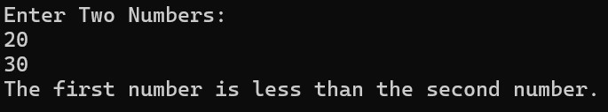

  - Task 2: Logical Operators:
        - Write a C program that prompts the user to enter an integer.
        - Use logical operators to check if the entered number is greater than 0 and less than 100.
        - Display a message indicating whether the number meets both conditions or not.

- Input:
#include<iostream> using namespace std;
int main()
{
int num;
cout<<"Enter an integer: "<<endl;
cin>>num;
if(num>0 && num<100)
{
cout<<"The number is greater than 0 and less than 100.\n";
}
else
{
cout<<"The number does not meet the condition.\n";
}

return 0;
}

- Output:
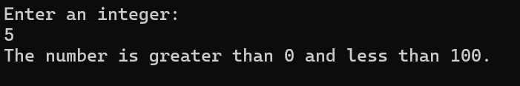

  - Task 3: If Statement:
        - Write a C program that prompts the user to enter an integer.
        - Use an if statement to check if the entered number is positive.
        - Display a message indicating whether the number is positive or not.
- Input:

#include<iostream> using namespace std;
int main ()
{
int num;
cout<<"Enter an integer: "<<endl;
cin>>num;
if(num>0)
{
cout<<"The number is positive.\n";
}
if(num<0)
{
cout<<"The number is not positive.\n";
}

return 0;
}

- Output:
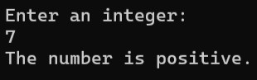

  - Task 4: If-else Statement:
      - Write a C program that prompts the user to enter their age.
      - Use an if-else statement to check if the entered age is greater than or equal to 18.
      - Display appropriate messages for both conditions.

- Input:
#include<iostream> using namespace std;
int main ()
{
int age;
cout<<"Enter your age: "<<endl; cin>>age;
if(age>=18)
{
cout<<"You are eligible for Vote. "<<endl;
}
else
{
cout<<"You are not eligible for Vote. " <<endl;
}

return 0;
}

- Output:
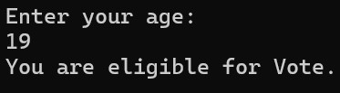

  - Task 5: Else-if Statement:
      - Write a C program that prompts the user to enter an integer.
      - Use an else-if statement to check if the entered number is positive, negative, or zero.
      - Display appropriate messages based on the entered number.

- Input:
#include<iostream> using namespace std;
int main ()
{
int num;
cout<<"Enter an integer: "<<endl;
cin>>num;
if(num>0)
{
cout<<"The number is positive.\n";
}
else if(num<0)
{
cout<<"The number is negative.\n";
}
else
{
cout<<"The number is zero.\n";
}

return 0;
}

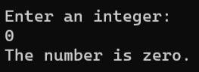


Output:

•

Conclusion

In this lab, we learned:
  - How to use relational operators for comparison
  - How to use logical operators for multiple conditions
  - How to implement decision making using o if statement o if-else statement o else-if statement
These concepts are essential for controlling program flow and making decisions in C++ programming.

